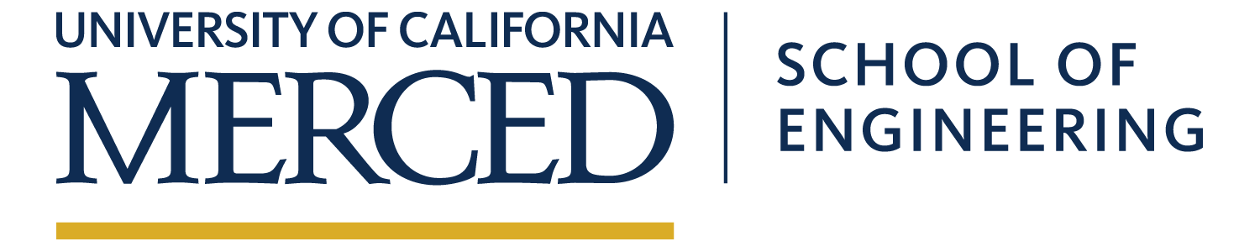  Electrical Engineering and Computer Science Technical Seminar Series  Friday, December 6, 2019  12:00 PM in COB 263  Runtime Data Management on Non-Volatile Memory-Based High Performance Systems  Kai Wu  Faculty Host: Dong Li  Abstract  Non-volatile memory (NVM) is expected to substitute DRAM in the memory hierarchy, due to the strengths of non-volatility, high density, and near-zero standby power. However, comparing with DRAM, NVM as main memory can be challenging. First, promising NVM solutions (e.g., PCM, ReRAM, and 3D XPoint), although providing faster data access speed than storage devices (e.g., hard drive and SSD), can have higher latency and lower bandwidth than DRAM. As a result, NVM is often paired with DRAM to build a heterogeneous memory system (HMS). HMS must carefully place application data to NVM and DRAM for the best performance. Second, data on NVM is not lost when the system crashes because of the nonvolatility nature of NVM. However, because of volatile caches, data must be explicitly flushed from processor caches into NVM to ensure consistency and correctness before crashes, which can cause significant runtime overhead. My research work explores using system software solutions to address these challenges. In the first part of my talk, I will talk about Unimem, a lightweight runtime that can automatically and transparently manage data placement on HMS without the requirement of hardware modifications and disruptive change to applications. In the second part, I will introduce Ribbon, a runtime system that improves the performance and efficiency of the cache-line flushing (CLF) mechanism through concurrency control, proactive CLF, and coalescing CLF.  For additional information contact Prof. Wan Du <dli35@ucmerced.edu> | Kai Wu  UC Merced  Biography  Kai Wu is currently a Computer Science and Engineering Ph.D. candidate working with Professor Dong Li at the University of California, Merced. Before coming to UC Merced, he received his Master’s degree in Computer Science and Engineering from Michigan State University in 2016. He did internships at Lawrence Livermore National Laboratory in 2018 and Los Almos National Laboratory in 2017. His research interests span operating systems, distributed systems, high-performance computing, and computer architecture, with a current focus on building fast and reliable heterogeneous memory/storage systems for the next generation of supercomputing and data centers. He has published seven peer-reviewed high-quality papers in prestigious ACM and IEEE conferences, such as SC, ICPP, CLUSTER, and NAS.  abora
soegrads@ucmerced.edu

